# Introduction

The purpose of this document is to describe how to configure the Nitro board for use with the LPRS “easyRadio Companion software” while describing a test sequence to verify the assembly of the eRIC Nitro board and to verify the eRIC module is capable of transmitting and receiving data from another eRIC module.

# eRIC Nitro board testing

Suggested test sequence,

1. Test the eRIC module in standalone mode
2. Test the Arduino in standalone mode
3. Test the Arduino communication with the eRIC using Arduino software UART
4. Test the Arduino communication with the eRIC using Arduino hardware UART

## Test setup – eRIC module in standalone mode

To test eRIC module in standalone mode on Nitro board (verifying part of the eRIC PCB design and PCB assembly), requires,

1. 1 x assembled Nitro board, fully populated including all components including SIL headers strip and wire antenna (see later)
2. 1 x FTDI – USB-serial cable (USB to UART cable with +3.3V TTL level UART signals e.g. Farnell TTL-232R-3V3 <http://bit.ly/2gryNGJ> )
3. 1 x female-female jumper or jumper cable
4. 1 x Windows PC
5. 1 x LPRS easyRadio Companion software (see later)

# Test Procedure – step 1

1. At this point it is assumed that the Nitro board has been checked to confirm (at least) there are no short circuits between Nitro board Vin and GND (0V) pins and 3.3V and GND(0V) pins.
2. The LPRS website page <http://www.lprs.co.uk/resource-centre/downloads/eric-software-datasheets/eros-4-files.html> contains the documentation and software for the eRIC module

Download and install the easyRadio software from <http://www.lprs.co.uk/assets/media/easyRadiosetup%204.0.5.exe>

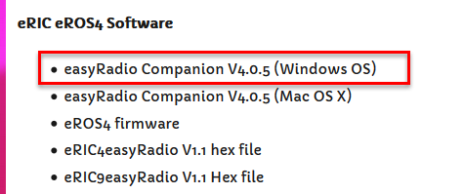

.

1. Get your FTDI cable ready. **Don’t connect it to the Nitro or PC just yet and make sure there is no power applied to the board**.
2. Get the Nitro board ready as follows,
3. Populate the Nitro board FTDI header (**K4**) with a male 6 pin header so that it can mate with the female end of a FTDI connector. The board below shows a SMA connector (**6**) added to the board but this is not necessary if using only a wire antenna

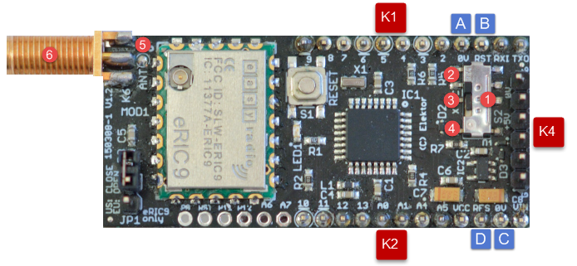

1. There are 2 options for a board level antenna. Either connect an SMA antenna (to **6**) or solder a simple (¼ wavelength) wire antenna to the board (at **5**). The antenna length for an eRIC9 module is 86mm. For a eRIC4 module it is 173mm.

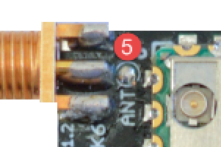

1. Using a jumper, connect the Nitro **RES** pin (**D**) to 0V (**C**), as this will force all ATMega328 pins into high impedance state when power is finally applied to the board.

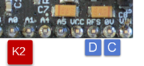

* + **Note**: there is a separate reset pin (**B**) **RST** for the eRIC module. Leave this unconnected and do not confuse it with **RES** pin (**D**), which is the ATMega328 reset pin.

1. Put Nitro board switch S2 (**1**) into middle position (**3**) so that the SDO/SDI pins of the eRIC are directly connected to the FTDI header (**K4**) RXI/TXO pins, bypassing the ATMega328 RXD/TXD pins.

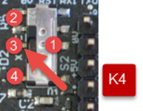

1. Connect the FTDI cable to the Nitro FTDI header (**K4**). Pay special attention to make sure the cable header polarity is correct – the FTDI GND pin (black cable) must mate with the Nitro FTDI header (**K4**) GND pin, and the FTDI +5V/VCC pin (red cable) must mate with the Nitro FTDI header (**K4**) +5V/VCC pin. Once this is done, connect USB end of FTDI cable to computer USB port. This will power up the Nitro board including the eRIC.

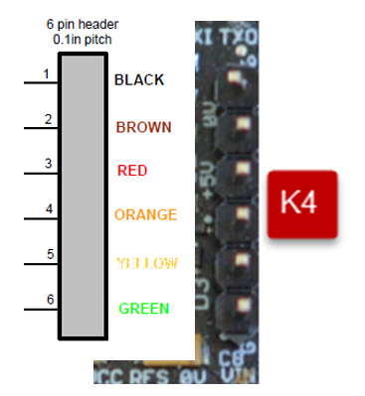

1. Start the easyRadio software

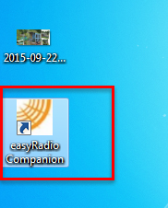

1. This will open a dialog box, but you can select “Not Now” to skip this section

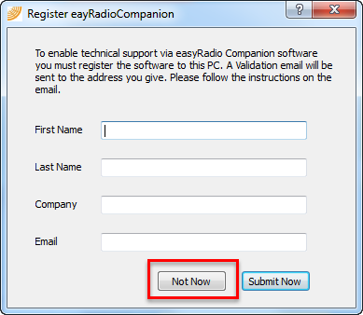

1. Select eRIC radio button (1) and then “OK” button (2) to select the eRIC module

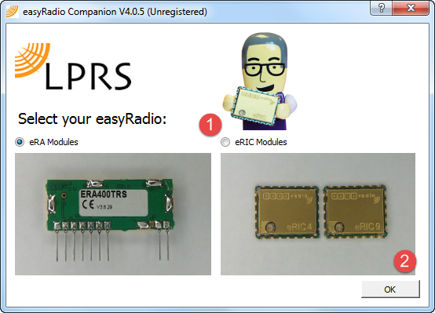

1. Next setup the FTDI serial connection settings from within the easyRadio software.
2. Select the appropriate port from drop down list (1)
3. Leave the baud rate(2) at whatever value it is set at, since the easyRadio software will try and auto detect the eRIC baud rate, and the value (2) may change.
4. Set handshaking as none (3)
5. Click on the “Open port” button to open the FTDI virtual COM port (4).

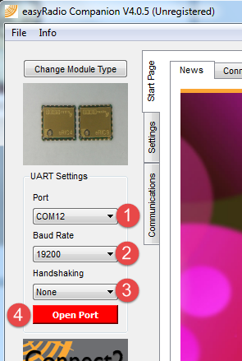

1. Click on the settings (1) and the then the module info (2) tabs.

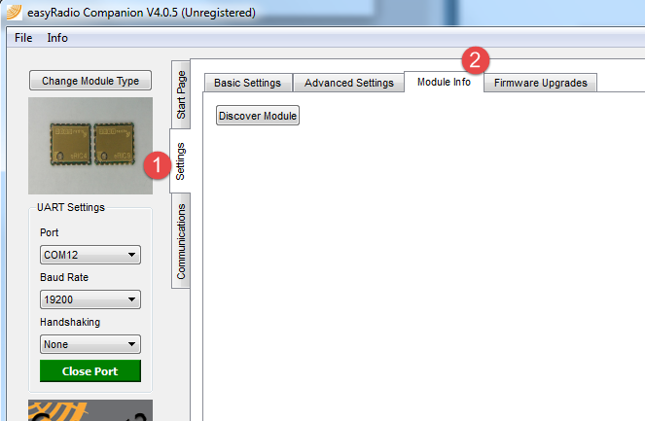

1. Click on “Discover Module” (1). The easyRadio software will try and autobaud connect to the eRIC module on the specified port.

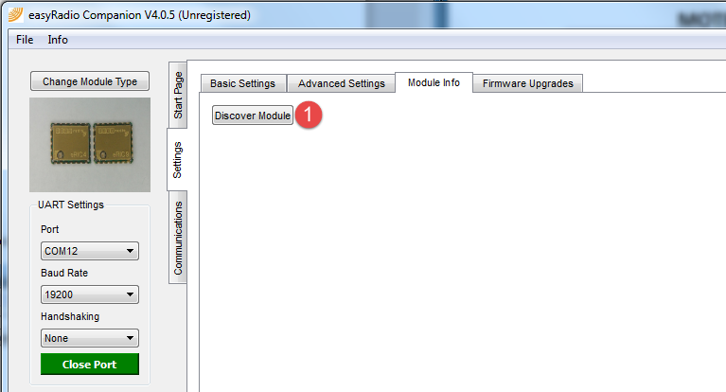

If all is okay (i.e. eRIC not dead, no problems with FTDI cable TXD/RXD to eRIC SDI/SDO connections or power to eRIC etc.), then you should see a screen similar to the one below, where all of the information related to App Code, OS, BSL etc. has been read from the eRIC module over the FTDI TXD/RXD interface.

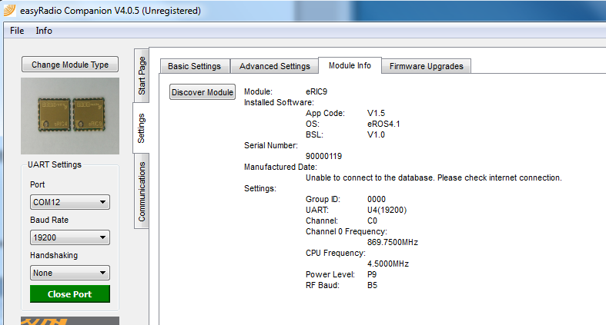

This is a good sign that the basic eRIC-FTDI electrical connections are good. To verify the PCB design and assembly further needs a second eRIC module and another set of test steps. See next section.

# Test Procedure – step 2

Step 2 requires another Nitro board to be assembled and tested as per step 1. This will require a second FTDI cable and a second female-female jumper.

Confirm the 2nd Nitro board hardware by repeating actions 1, 3-10 from step 1 above. No action 2 is necessary if the easyRadio software has already been downloaded and installed. Both Nitro boards must be of same type i.e. both eRIC4, or both eRIC9, and both must have same firmware revision.

We can now test the RF interface.

1. Close all instances of the easyRadio software.
2. Remove FTDI cables from PC.
3. Connect **first** FTDI cable to 1st Nitro board and insert FTDI cable USB to PC.
4. Connect **second** FTDI cable to 2nd Nitro board and insert FTDI cable USB to PC.
5. Keep both Nitro board at least 30cm apart to avoid RF swamping i.e. avoid overloading Nitro 2 radio receiver with too large a signal from Nitro 1.
6. Open easyRadio software and repeat action 6, 7, 8 for 1st module. Then select communications tab (1)

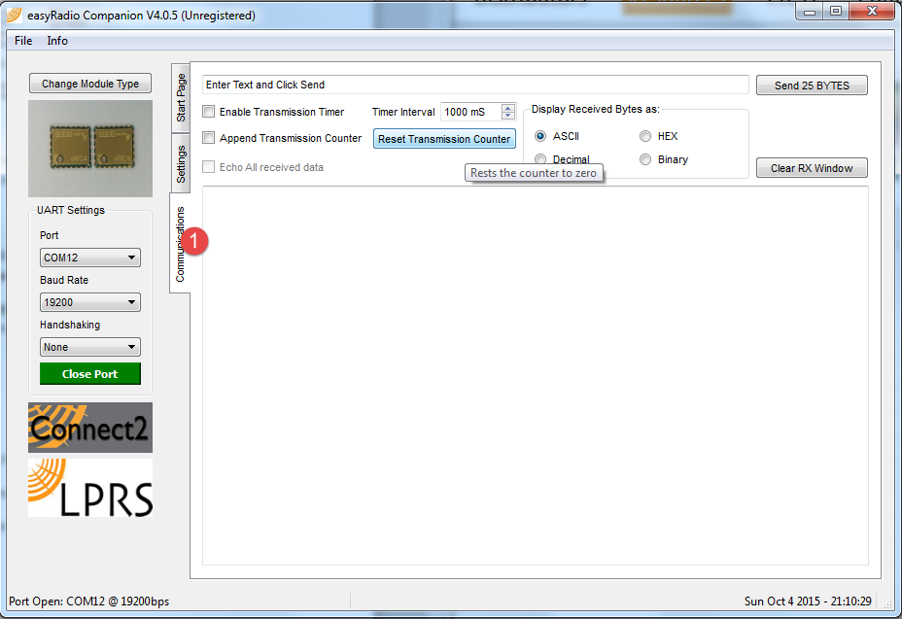

1. Open second instance of easyRadio software and repeat action 6, 7, 8 for 2nd module. Then select communications tab (1) again in second instance. On your screen you might see something like this, (In this image we have 2 Nitro boards connected to COM port 12 and 15 on the test PC.)

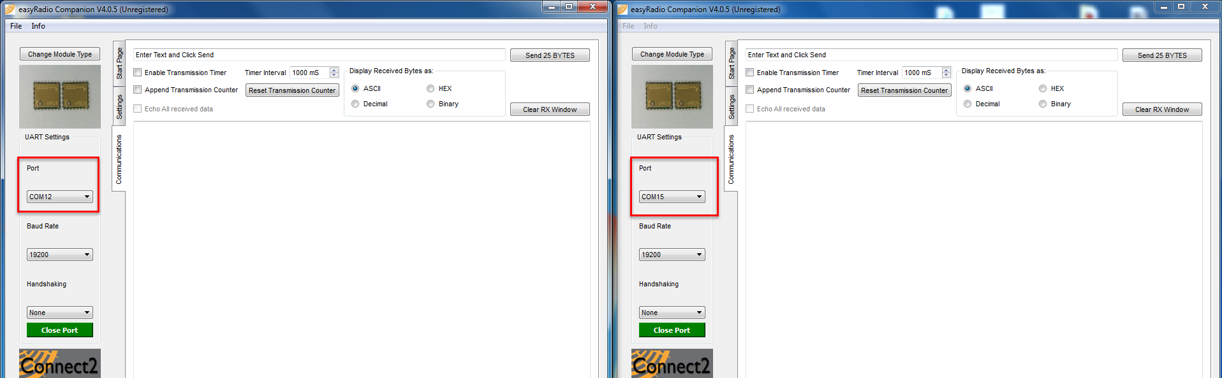

1. On 1st instance of software at (1) type in a message to be sent to 2nd Nitro board, then click on Send button (2). If all is okay and Nitro 2 is receiving , then the message from Nitro 1 should appear on Nitro 2 at (3)

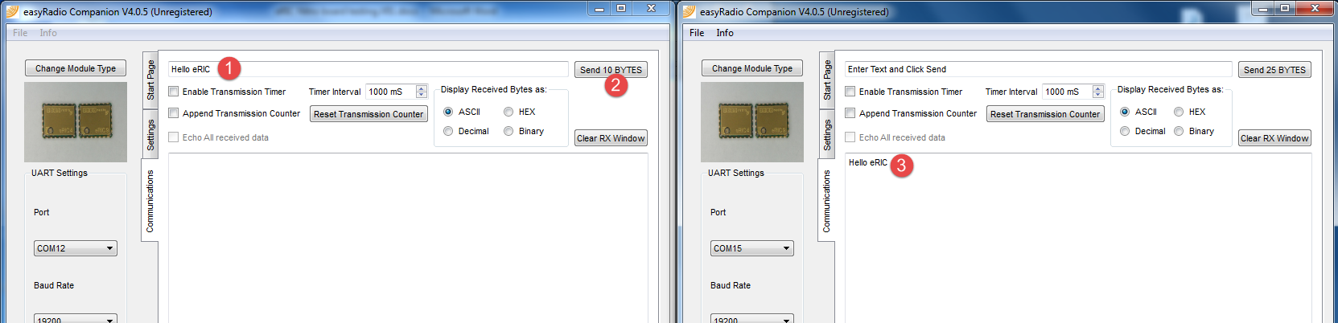

# Document revisions

|  |  |
| --- | --- |
| **Revision** | **Description** |
| V01 | Initial version |
| V02 | Updated to clarify switch and jumper configuration for eRIC Nitro use with LPRSTM **easyRadio Companion** software |

=== end of document ===